Contents
1. Annual Audit Planning information 2
2. ExAnte Assurance Heatmap 5
3. Organisational 5
4. Audit Object L2 actualization 6
5. Process based information 7
5.1. L2 117-01-IT-Operations Governance 7
5.2 L2 117-04-IT Asset Management, Configuration Management and Licence Management 27
5.3 117-05-IT Operations Management 31
5.4 117-06-Capacity Management and Storage Management 35
5.5 117-011-Cloud operations 37

Annual Audit Planning information
117-01-IT-Operations Governance
Risk Assessment | Low
Relevant for LE | DBAG/ExR/EFAG/ECAG/CBF/CBL/LuxCSD/CS/CI/CFCL
Changes to RCA | N/A
L2 Additional info | N/A

 | DBAG | CBF | ECAG | CBL | CFCL
IA Judgement | Low | Low | Low | Low | Low
Regulatory required audit frequency | N/A | N/A | N/A | N/A | N/A
Comment | Frequency defined by the risk assessment | Frequency defined by the risk assessment | Frequency defined by the risk assessment | Frequency defined by the risk assessment | Frequency defined by the risk assessment

117-04-IT Asset Management, Configuration Management and License Management
Risk Assessment | Low
Relevant for LE | DBAG/ExR/EFAG/ECAG/CBF/CBL/LuxCSD/CS/CI/CFCL
Changes to RCA | N/A
L2 Additional info | Focus will be more on the IT Asset Management / Configuration Management part – License Management was prior year focus. Software License Management was assessed as Out of Scope for this year.

 | DBAG | CBF | ECAG | CBL | CFCL
IA Judgement | Low | Low | Low | Low | Low
Regulatory required audit frequency | N/A | N/A | N/A | N/A | N/A
Comment | Frequency defined by the risk assessment | Frequency defined by the risk assessment | Frequency defined by the risk assessment | Frequency defined by the risk assessment | Frequency defined by the risk assessment

117-05-IT Operations Management
Risk Assessment | Low
Relevant for LE | DBAG/ExR/EFAG/ECAG/CBF/CBL/LuxCSD/CS/CI/CFCL
Changes to RCA | N/A
L2 Additional info | Testing will have a focus on DORA requirements where applicable (e.g. how timeliness of Incident Reporting to regulator is ensured etc.)

 | DBAG | CBF | ECAG | CBL | CFCL
IA Judgement | Low | Low | Low | Low | Low
Regulatory required audit frequency | N/A | N/A | N/A | N/A | N/A
Comment | Frequency defined by the risk assessment | Frequency defined by the risk assessment | Frequency defined by the risk assessment | Frequency defined by the risk assessment | Frequency defined by the risk assessment

117-06-Capacity Management and Storage Management
Risk Assessment | Low
Relevant for LE | DBAG/ExR/EFAG/ECAG/CBF/CBL/LuxCSD/CS/CI/CFCL
Changes to RCA | N/A
L2 Additional info | N/A

 | DBAG | CBF | ECAG | CBL | CFCL
IA Judgement | Low | Low | Low | Low | Low
Regulatory required audit frequency | N/A | N/A | N/A | N/A | N/A
Comment | Frequency defined by the risk assessment | Frequency defined by the risk assessment | Frequency defined by the risk assessment | Frequency defined by the risk assessment | Frequency defined by the risk assessment

117-11-Cloud operations
Risk Assessment | Medium
Relevant for LE | DBAG/ExR/EFAG/ECAG/CBF/CBL/LuxCSD/CS/CI/CFCL
Changes to RCA | N/A
L2 Additional info | N/A

 | DBAG | CBF | ECAG | CBL | CFCL
IA Judgement | Medium | Medium | Medium | Medium | Medium
Regulatory required audit frequency | N/A | N/A | N/A | N/A | N/A
Comment | Frequency defined by the risk assessment. Not covered in prior year. | Frequency defined by the risk assessment.  Not covered in prior year. | Frequency defined by the risk assessment.  Not covered in prior year. | Frequency defined by the risk assessment.  Not covered in prior year. | Frequency defined by the risk assessment.  Not covered in prior year.

121-11-CSDR IT-Operation Management
Risk Assessment | High
Relevant for LE | CBF/CBL/LuxCSD/CS/CI
Changes to RCA | N/A
L2 Additional info | N/A

 | CBF | CBL
IA Judgement | High | High
Regulatory required audit frequency | Yearly | Yearly
Comment | High due to CSDR requirements for CBF and CBL LEs (including LuxCSD)

ExAnte Assurance Heatmap
Most recent Ex-Ante Heatmap indication of residual risk (forward looking view)
ExAnte Assurance Heatmaps
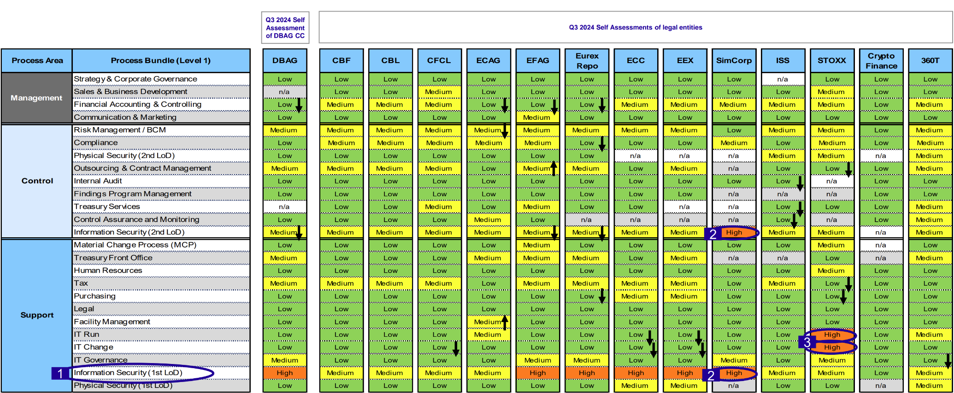
IT Operation Management is part of IT Run. In general, the rating for the Legal Entities in scope is low. ECAG classified/increased to “Medium” due to the dedicated involvement in internal and Group Projects e.g. Ameli, which could lead into the temporary shortage of staff for daily operations.

Conclusion: No change to the initially planned approach of the Audit.

Organisational
IT Operation Management helps to maintain and improve the availability and performance of IT systems and services including capacity and storage management, which are essential for the smooth operation and growth of any business. Under IT Operation Management, IT Incident Management contributes to restoring normal service operation as soon as possible and minimising the adverse impact on business operations, thus ensuring agreed-upon levels of service quality are maintained. The Problem Management process manages the whole lifespan of all IT problems and ensures that each problem is properly documented and resolved.

A review of the organisational charts revealed that major organisational changes in the responsibility of the process owners were applied by end of 2023. No re-organizations have occurred since the last audit.

This audit comprehends multiple departments/sections/units in the 1LoD:
The division CIO/COO (Chief Information Officer/Chief Operation Officer) acts as the 1st LoD - central IT function for developing, running and providing technology solutions to Deutsche Börse Group (DBG). The CIO/COO division is subdivided into –
- IT Governance, Risk and Transformation (IRT) department responsible as the center of excellence for IT Governance, IT Core Processes and IT Transformation to provide smart and practical guidance and helping hands to all IT teams across the group. The IT Core Process Design & Operations (ÜPÜ) unit under IRT is responsible for documenting and maintaining the IT Operations’ processes for group-wide usage of Incident Management, Problem Management, IT Asset Management, etc.
- Five key IT Product Groups namely Chief Technology Officer – CTO (ZJS), Corporate IT (ITH), Post Trade (ZJT), Clearing and Risk IT (ITC), Derivatives & Cash Trading IT (ITJ) are responsible to develop and deliver specific IT, data management solutions and utilise new technologies for DBG pre-trading, trading and post-trading markets.

The CTO department is responsible for implementing / delivering key projects, initiatives, and technological advancements across DBG to accelerate digital transformation. This is driven by its key sections namely, Data-aaS, Cloud/Infrastructure, DevSecOps Tools & Operations, Transformation Office and Enterprise Architecture & Digital Innovation.

The Derivatives & Cash Trading IT department performs the technical IT operations of Eurex and Xetra's clearing and risk management systems. They also manage IT run operations such as incident, problem, and capacity management for trading platforms, as well as trade support systems for DBG's Eurex and Xetra markets.

Additionally, to the on-site processes on IT Operation, the Corporate IT Cloud Operations Department (GAL) oversees all cloud-related operations for DBG. The department is part of the new DBAG Branch Luxembourg, established in 2024.

The Post Trade IT Operations and Governance area is responsible for the operation and maintenance of the regular Clearstream Luxembourg IT landscape as well as the Mainframe area for Clearstream Banking AG.

In the Second Line of Defense, the IS Assurance team (KIU) conducts assessments on the IT Operations areas confined to IT security risks and did not address IT Run risks of processes in scope of this audit. Furthermore, as part of the Group Compliance Strategy (SCG) annual plan, SCG conduct control testing for the IT Run area.

Type of risk to be assessed out of this chapter:
Transformation Risk/ Employee Dependency Risk
Operational Risk: People Risk / Staff Unavailability

Audit Object L2 actualization

In the context of the newly active DORA regulation, the audit will additionally have limited focus on the 2025 out-of-scope L2 Processes 117-02-Change Management and 117-03-Incident & Problem Management as part of the L2 process 117-05-IT Operations Management.
117-02 as well as 117-03 will be scoped in with a limited perspective on the arrangements regarding the timeliness of ICT Incident Reporting according to DORA Art. 17-23 – Cyber Security Incidents excluded. As this change of L2 Scoping may have implications on the other L2 Processes allocated in 2025 for IT Operation Management, the analysis in “5. Process based information” below included this information wherever necessary. Testing of Operating Effectiveness needs to be taken in scope of next planned regular audit.

117-04-IT Asset Management, Configuration Management and Licence Management will be covered to a limited extent due to the overlapping of coverage with the 2025-024 SA General Controls Audit. A dedicated scoping will be done in alignment with the testing planned here. This year, the Licence Management Process is outscoped considering the exhaustive review performed in the prior year and an open finding with ongoing remediation measures due in March 2025.

Process based information

5.1. 117-01-IT-Operations Governance

Topic | Review and results
Process description | IT governance frameworks (incl. IT Operations) are designed so organizations can reduce the likeliness of risks and losses due to unethical or improper management of data, technology, and business operations. A robust IT governance framework clarifies roles, responsibilities, and accountability within IT operations. The ambition of IT Operations Governance is spread across the whole group with definition of policies governing the area of IT Operations and setting the baseline for the management and maintenance of IT infrastructure within the Group.  The risk of not having a transparent and clear governance including the definition of roles and responsibilities around the IT Operations is having malfunctioning IT Systems/IT Application. Incidents may not be properly resolved or addressed in a timely manner, leading to an impact on the Group’s business.  Changes in the process: none identified so far.
Relevant Organizational structure | Refer to Section 3: Organisational – related data and information listed there are applicable here, too.  Conclusion for RCA: under this L2, add a test procedure to verify whether IT Governance framework/policy has been defined, which clearly states the role and responsibilities along with ownership for managing governance and operations of IT Management processes.
Key business indicators | The concept of key business indicator is to achieve a measurement of dedicated, specific targets to be achieved in an area or even for a whole company:  Incident and Problem Management: DBAG IT Core Process Design & Operations (ÜPÜ) team is responsible for defining and monitoring the Key Performance Indicators (KPI) for Incident and Problem management process for all IT Product teams, which have a service agreement with them.  Incident and Problem Management KPI´s and goals against which product teams of DBAG and legal entities are monitored and reported is attached here.  The KPI´s defined for Incident Management process are reported as part of the reports given in the screenshot shown below:  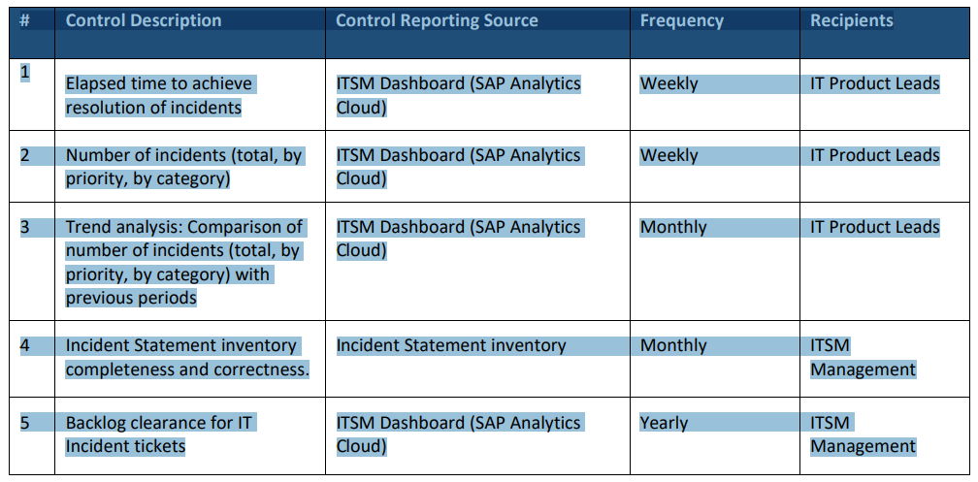  The KPIs related to Problem Management get reported to Problem Control Board (PCB) on monthly basis.  The performance metrics that have been established as key performance indicators can be considered/assessed as suitable for performance monitoring of the incident and problem management process. Furthermore, KPIs are provided to relevant management forums on a regular basis.  IT Asset Management, Configuration Management: SAP CMS - ITAM KPI Reports per legal entity are generated weekly (here):  - AM1: Consistency between Financial Asset Inventory and Physical Asset Inventory  AM2: Consistency between SAP CMS and Financial Asset Inventory  - CM1: Completeness of Configuration Item mandatory attributes in CMS  - CM2: Correctness of Configuration Items in CMS (Orphans)  - CM3: Correctness of Configuration Items in CMS (Duplicates)  - CM4: Compliance of Configuration Item data (expected vs. actual values)  Cloud CoE monitoring: Cloud Center of Excellence performs the initial setup and configuration of the cloud public infrastructure and take care of overall operational aspects like security monitoring and billing. It enables the product teams, so that they can develop, migrate and operate applications efficiently in the cloud.  Cloud CoE monitors performance along the outsourcing chain: reporting the KPIs agreed in the intercompany contracts with the different Legal Entities for the provisioning of cloud services. Monitoring the SLAs agreed in the contracts with the Cloud Service Providers (CSPs). Last but not least, they monitor if the CSPs and their sub-contracts are in line with our sub-outsourcing monitoring approach. KPIs - overview, targets & links per CSP:  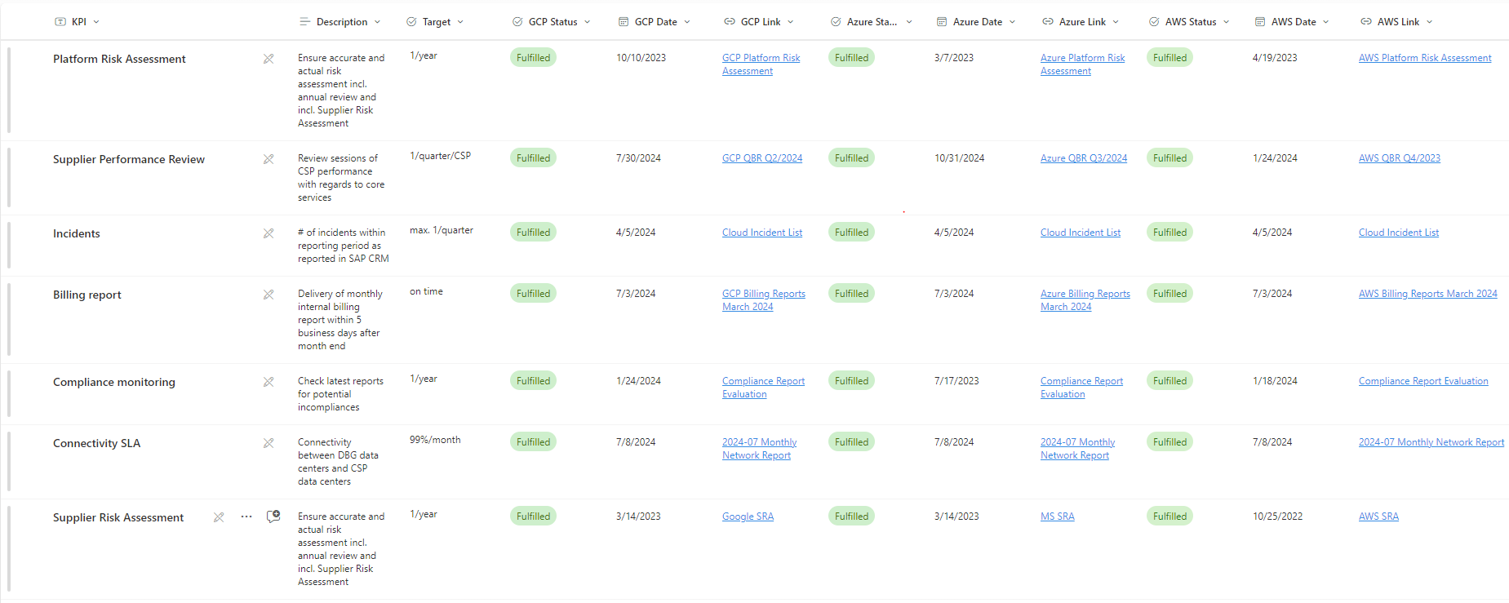  Digital Security Committee (DSC): it serves as monthly forum to monitor DBAG resilience level of individual areas of the security universe, where KPIs are shared (here), as for example:  - Inventory and Control of Enterprise Assets  - Secure Configuration of Assets and Software  - Inventory and Control of Software Assets  - Incident Response Management  IT Governance Committee (ITGC): It serves as monthly forum to monitor and discuss the execution of the holistic IT Governance System with the purpose to assist senior management of the CIO/COO Division in its ongoing IT Governance and management of IT Risks.  Find below the defined management KPIs encountered (here):  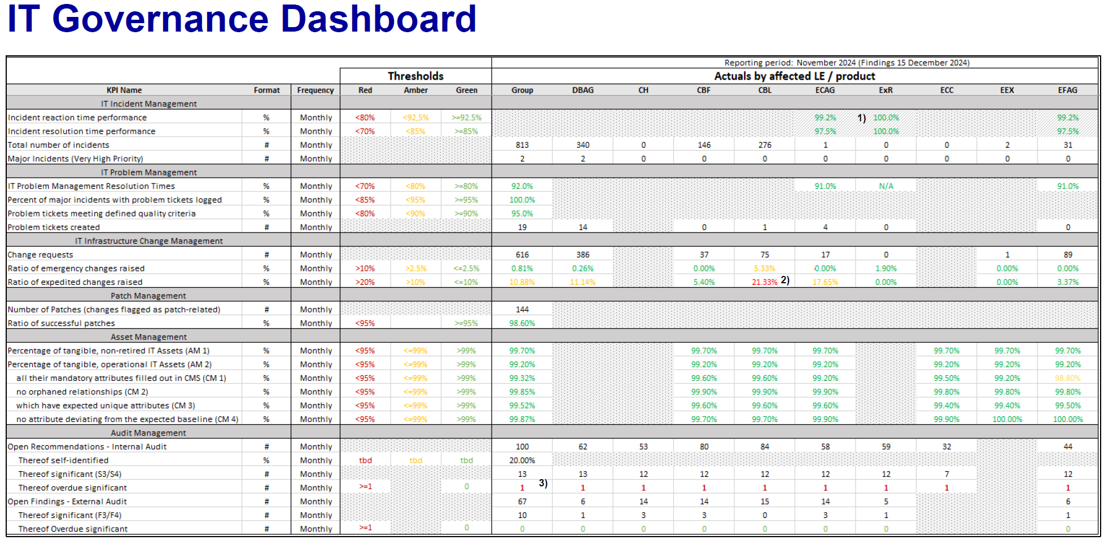  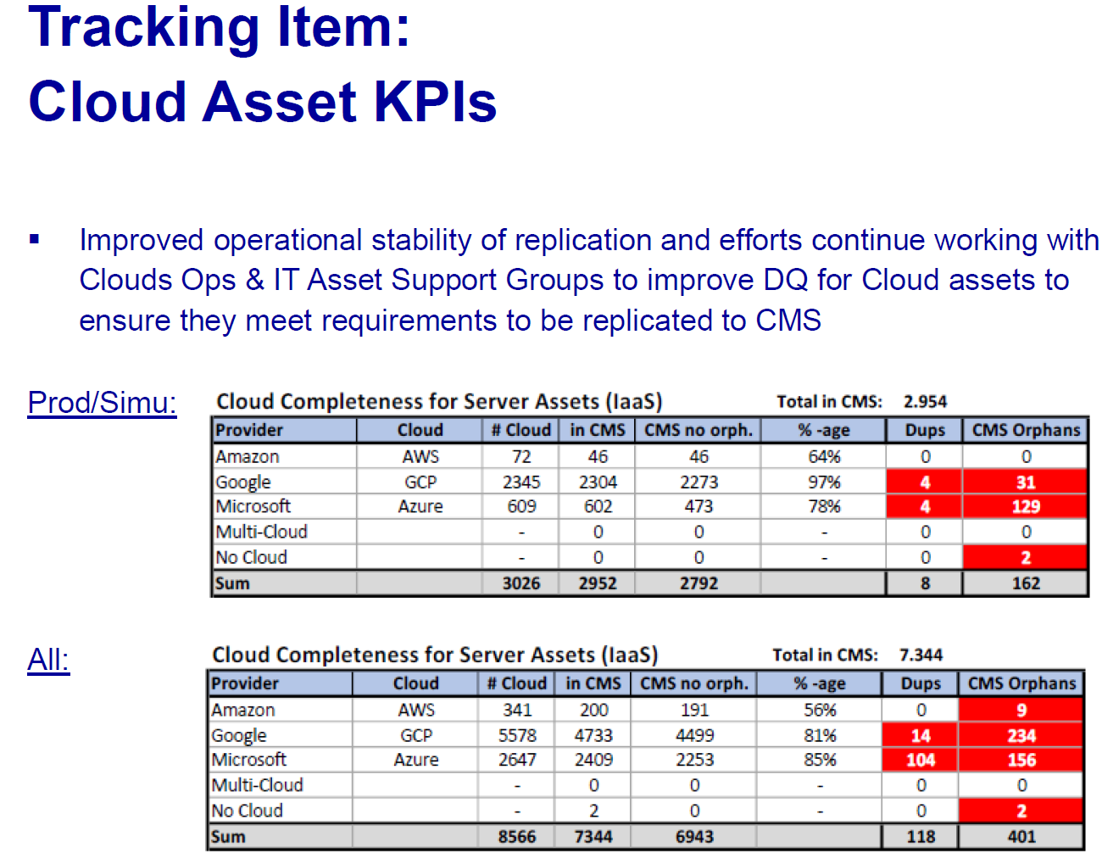  Note: CFCL LE not represented in the IT Governance Committee (ITGC).  Conclusion: See TP4 for L2 117-01-IT-Operations Governance.
Relevant legal and regulatory requirements | As part of the evaluation process, IA determined the following external criteria as being generally applicable – when relevant as subsequently amended:  - EMIR Article 26 of Commission Delegated Regulation (EU) No 648/2012  - Commission Delegation Regulation No 153/2013 (supplementing regulation (EU) No 648/2012) - Article 3 Governance arrangements and Article 9 Information technology systems  - Central Securities Depositories Regulation (CSDR) (EU) No 909/2014, updated on 22 Jun 2022 –Art 75, 45  - Central Securities Depositories Regulation (EU) 2017/392 of 11 November 2016, Chapter X - Operational Risks, Article 75  - MiFID II Articles 47, 49, 75 of Commission Delegated Regulation (EU) 2017/392 of 11 November 2016  - European Securities and Markets Authority (ESMA) RTS - Commission Delegated Regulation (EU) 2017/392 of 11 November 2016 supplementing Regulation (EU) 909/2014. Articles: 15(1, 2); 53(3); 70(1, 2, 9); 71(3, 4); 75(1, 4, 5, 7, 9); 78(1).  - Regulation No 648/2012 of the European Parliament and of the Council with regard to regulatory technical standards on requirements for central counterparties (EMIR RTS 153/2013) with focus on Article 9 “Information technology systems”  - EBA/GL/2019/04 guideline on ICT and Security Risk Management  - EBA/GL/2019/02 revised EBA Guidelines on outsourcing arrangements  - BaFin Circular 06/2024 (Minimum Requirements for Risk Management – MaRisk): AT 4.3 (internal control system), AT 5 (organisational guidelines), AT 6 (documentation), AT 7.2 (technical and organisational resources), AT 7.3 (contingency planning) and AT 9 (outsourcing)  - BaFin Circular 10/2017 updated on 16.08.2021 (Supervisory Requirements for IT in Financial Institutions – BAIT) – principles 1 (IT strategy), 2 (IT governance), 3 (information risk management), 4 (information security management), 5 (operational information security), 7 (IT projects and application development), 8 (IT operations), 9 (outsourcing and other external procurement of IT services), 10 (IT service continuity management), 12 (critical infrastructure)  - Law of 5 April 1993 on the financial sector, Luxembourg  - NIS2 - Directive (EU) 2022/2555  - Protection of Critical Infrastructures – Baseline Protection Concept (KRITIS)  - CSSF Circular 12/552– Central administration, internal governance and risk management, Luxembourg.  - CSSF Circular 22/805 of 22 April 2022, which repealed the CSSF Circulars 15/611 and 17/656 on outsourcing arrangements, Luxembourg  - CSSF Circular 17/654 (IT outsourcing relying on a cloud computing infrastructure), Luxembourg.  - CSSF Circular 22/806 on outsourcing arrangements (regarding ICT outsourcing arrangements), Luxembourg  - CSSF Circular 20/750 Requirements regarding information and communication technology (ICT) and security risk management, Luxembourg.  - Monetary Authority of Singapore (MAS) Technology Risk Management Guidelines of January 2021  - Technology Risk Management Guidelines, Singapore  - Information Security Management System (ISMS) Standard: ISO 27001/2:2013 and 2021  - Digital Operational Resilience Act (DORA) - Regulation (EU) 2022/2554 requires financial entities to improve their digital operational resilience. DORA Arts - 4 (1, 2), 5 (1, 2), 6 (2), 7, 8 (1, 4, 6, 7), 9 (1), 13 (2), 17, 18, 19, 24 (3).
Relevant internal requirements | Applicable internal requirements are:  Policies - Link to the official DBG Policy Database  ICT Risk Guidelines - Link to the official DBG Information Security Standards Database  Standards (published in March 2024)  - Information Security Management Standard v4.0  - Technological Security Standard v1.0  - Third-Party Security Standard v4.0  Guidelines (published in January 2025)  - ICT Asset Management v1.0  - ICT Operations v1.0  - ICT Risk Management v1.0  - Software Development and ICT Change Management v1.0  - Third-Party ICT Risk Management v1.0  Note: Standards setup change 2023 (link) and 2024 (link)  The above is facing significant changes as described below:  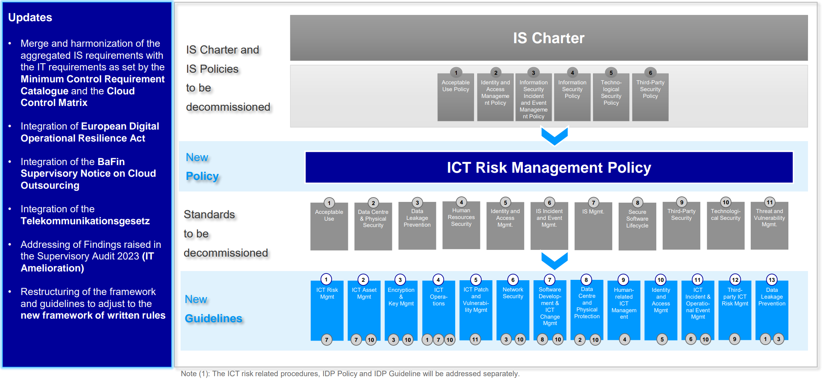  DBG Written Rules Database (link)  Clearstream IT Written Rules Repository: IT Handbooks of the Clearstream Legal Entities  IT Governance Artifact Library: part of the IT Governance Framework and consists of two main parts: Requirements Definition (IT Governance Policy and IT Standards) and Operationalisation (IT Process Guidelines / Core Process Documents and other optional IT Supporting Documents)  Procedures / Processes:  IT Asset Management/Configuration management  - Maintenance Contract Management Process v1.7  - Configuration_Management_Process_v1.8  - IT_Asset_Management_Process_v1.10  - IT Infrastructure Change Management Process v1.8  Capacity Management and Storage Management  - Backup Restore Management Process Description v2.1.4  - Data Backup Strategy Mainframe Operations 6.5  - XEOPS Monitoring 2024  - XEOPS Storage Management 2024_V1.0  - 2024_OPR_GAE_170 – Monitoring & Reporting  - Storage Management Process v1.05  IT Operations Management  - IT Operations Management (Clearstream) v5.0 01 2024  - SLM Service Level Management Process v25.0  - Clearstream IT Ops Alert Notification Escalation Procedure v16.5  - IT Problem Management Process v2.3  - IT Request Management Process v1.4.2  - INR130075 - T7 Production data usage  - IT CTO and IT DATA (document link)  Availability and Capacity Management  - Availability Management (ICSD) Process v6.0  - Capacity Management (ICSD) Process v3.9  - Performance Management (ICSD) Process v2.6  - INR43006 - F7 Capacity Management Governance in Trading IT  Cloud Operations  - COOL_Ops_Manual_Apr_2024  Other  - CIF Identification Procedure v1.0  General note: As per 1LoD, there are no pending changes on procedures.  Conclusion for RCA: The listed policies, standards and process documentation cover the key processes in scope of this audit. Versions for policies and standards are the most recent ones. No indication during preparation that the procedures and policy framework are not in adequation with process and sub-process complexity; further assessment during fieldwork if needed (see test under respective L2 – within RCA).  (TP2) Validate via a representative sample of Policies and Procedures, whether DORA Principles have been identified and translated into the governance arrangements available.
IT environment + Cloud services | No applications were identified as relevant to this L2 process as per the AAP2025 Golden Source. Refer to the L2 processes: 117-05-IT-Operations Management and 117-06-Capacity Management and Storage Management for IT Applications coverage.
Available Risk Management Data | Based on IA’s review of the 2024 ICT Risk Assurance covered topics; none were identified relevant for this audit processes.  GRM database risk scenarios exported from SAP GRC. Noted the following relevant scenarios:  ORS DBAG_AV017 - Overall IT Infrastructure Outage  ORS DBAG_AV032 - Shared Services Unav  ORS_C_AV004 – CSD Outage  ORS_C_AV036 – T2S Platform Outage  ORS_C_FR051 - IS & Cyber Risk  ORS_DBAG_BP012 - Unauthorised software  ORS_DBAG_EP001 - Confidentiality Breach  ORS_DBAG_FR016 - Confidentiality  ORS_DBAG_FR020 - Ransomware  ORS_DBAG_FR021 - Cyber Destruction  ORS_ECAG_FR001 Fraudulent misuse of appl  EFAG_AV007 - Common Software and Infrastructure Outage Eurex / Xetra T7  EFAG_AV001 - T7 Eurex outage  ORS_C_AV039_DNS – Production-Incidents  ORS_C_AV042_Loss of Data-CRM Cloud Opera  ORS_MDS_016 - Information Security Breach  No risks for further reviews noted from the scenarios.  No KRI breaches reported. No claim directly related to the process was opened since last audit.  Conclusion for RCA: No specific testing planned for fieldwork as no indication of insufficient coverage of risks has been identified.
Data from Compliance | Based on information available to IA, in particular CCO reports, Compliance control plans from past years did not identify any relevant IT Operations Management processes. IA assessed no additional tests to be added or applicable to risk assessment of all L2s.  Conclusion for RCA: (TP6) IA to check and validate with relevant personnel about the 2nd line (Risk/Compliance) activities in IT Operations area performed in the year under review
Data from Outsourcing | Currently, DBAG IT Core Process Design & Operations (ÜPÜ) unit is centrally responsible for the KPIs related to incident and problem management for all the entities. Each entity / product IT teams have their own incident and problem handling teams. These teams follow or align their processes with the standard processes defined by the Group. For IT Asset & Configuration Management, SDS are in place for each of the entity. Below are the SDS, which were identified/ provided during the planning phase:  DBAG:  CBL:  CBF:  CS:  CFCL:  ECAG:  Conclusion: Situation is still identical to 2024/prior years where the contractual arrangements were tested either in the IT Operations Management audit or in several other audits with the topic of IT Vendor Management.
  Service | Outsourcer | Insourcer | SDS
  IT Operation of F7 Repo Service | Eurex Repo GmbH | DBAG | MA-001903-2020
  Service | Outsourcer | Insourcer | SDS
  CBL-CS IT-Services | CBL | CS | MA-005577-2021
  Service | Outsourcer | Insourcer | SDS
  IT Asset & Configuration Management | CBF | DBAG | MA-000243-2019
  Service | Outsourcer | Insourcer | SDS
  IT Operation Monitoring and Processing | CS | DBAG | MA-006597-2017
  IT Asset & Configuration Management | CS | DBAG | MA-002735-2021
  Service | Outsourcer | Insourcer | SDS
  IT Asset & Configuration Management | CFCL | DBAG | MA-001097-2023
  Service | Outsourcer | Insourcer | SDS
  IT Incident and Problem Management | ECAG | DBAG | MA-002700-2020
  IT Asset & Configuration Management | ECAG | DBAG | MA-003838-2021
  IT Asset & Configuration Management | EUREX Frankfurt | DBAG | MA-000812-2020  MA-000815-2020
  IT Asset & Configuration Management | EFACG | DBAG | MA-000466-2022
Data from Internal Audit | Considered from past 2022-003 and 2024-009 audits, please see linked all relevant closed and open findings. No SIIs or audit comments were raised in either of them.  All findings raised in 2022-003 were already closed. Of all findings raised in 2024-009 three were already closed.  One open finding F02 regarding Software License Management with due date in March 2025 is still under implementation, with progress tracked by IA. Thus, a follow-up on open finding in this audit is not required.  Conclusion for RCA: No further testing required.
Data from External Audit | Based on review of findings from external audits, the open external findings are still under implementation with target date of completion in future. Hence, no specific test procedure is identified for fieldwork and no follow-up required.  Findings from external audits, data from FAR, sheet "Filtered" (Extracted finding for IT Run)  Data from CH-CBF-ECAG_IT_Outsourcing_Remediation (link).  Open external findings as received from IT Governance, Risk and Transformation (IRT) department (link).  Open external findings as received from Derivatives & Cash Trading IT (ITJ) department (link).  Further, IA observed no outstanding/open note resulting from the previous BaFin / CSSF audits findings validation (SFV - Significant Findings Validation) program as performed by IA (restricted link).  During the review, IA observed that some of the IT findings are directly mapped to Boris Link (IRT), who is identified as the ‘FAR Responsible Finding Owner’. IA would like to understand the IT Operations-related findings management and governance processes of non-severe findings (F1/F2 rated) to evaluate the effectiveness of monitoring of implementation steps and subsequent closure.  Conclusion for RCA: Refer TP5 for L2 117-01-IT-Operations Governance.  Understand the governance of IT Operations - related findings management, especially for non-severe findings (F1/F2 rated) and evaluate the monitoring controls pertaining to implementation of remediation actions and closure tracking of such findings.
Relevant Future notes | Here is the complete list of future notes assigned to this audit.  No relevant FuN identified for L2s: IT Operations Governance, Cloud Operations, Capacity and Storage Management.  According to the analysis, IA will consider the following FuNs during the fieldwork, details in respective L2s.  Conclusion for RCA: Refer TP3 for L2 117-01-IT-Operations Governance.
  Future Note ID | Mapped to L2 process
  210817083234 | IT Operation Management - Job Scheduling
  211217153616 | IT Asset Management - IT asset change request
  240313110328 | IT Asset Management
Outcome of initiation panel (as applicable) | This sub-chapter is aligned with identified focus points and risks.  No specific change as outcome from the initiation panel. Reference from Initiation Panel:  - Governance around the Processes in IT Operations  - Clear definition and assignment of roles and responsibilities  - Policies and Procedures defined  - Controls defined
Conclusion: Risk overview | Key business indicators  Type of risk to be assessed out of this chapter:  Operational Risk: Information Technology Risk / IT Run Risk  Operational Risk: People Risk/Human Error Risk  Operational Risk: Risk Management Risk  Conclusion: Refer TP4  Relevant legal and regulatory requirements  Type of risk to be assessed:  Operational risk-Processing and Execution Risk  Operational risk-Regulatory Compliance Risk  Operational risk-Regulatory compliance risk-Other Compliance risks  Operational risk-Contagion risk  Conclusion: The new EU Digital Operational Resilience Act (DORA) is applicable since 17 January 2025. Therefore, all the tests identified in the RCA will need to take it into account the DORA relevant requirements.  Relevant internal requirements  Type of risk to be assessed out of this chapter:  Operational risk-Processing and Execution Risk  Operational risk-Regulatory Compliance Risk  Operational risk-Information Technology risk  Operational risk-Data Integrity risk  Data from Outsourcing  Type of risk to be assessed out of this chapter:  Operational risk-Regulatory Compliance risk  Operational risk-IT Third Party Compliance Risk  Operational risk-In-/Outsourcing  Conclusion for RCA: The listed policies, standards and process documentation cover the key processes in scope of this audit. Versions for policies and standards are the most recent ones. However, assessment of the adequacy with DORA needs to be confirmed.
Defined test | This is also a direct input for RCA:  (TP1) Inquire with relevant personnel about the structure arranged in the context of governance around the IT Operations Area with focus on roles defined, responsibilities allocated and tasks to be performed in the context of monitoring and reporting regarding IT Operations per LE.  (TP2) Validate via a representative sample of Policies and Procedures, whether DORA Principles have been identified and translated into the available governance arrangements.  (TP3) Test the Future Notes identified as relevant to the respective L2s.  (TP4) During fieldwork, overall KPI reporting on in-scope processes will be assessed for completeness and appropriateness, especially if the reporting encompasses all product teams inside DBG. Also, assess why CFCL is not included in the IT Governance Committee KPIs.  (TP5) Understand the governance of IT Operations-related findings management, especially for non-severe findings (F1/F2 rated) and evaluate the monitoring controls pertaining to implementation of remediation actions and closure tracking of such findings.  (TP6) IA to check and validate with relevant personnel about the 2nd line (Risk/Compliance) activities in IT Operations area performed in the year under review

5.2 117-04-IT Asset Management, Configuration Management and Licence Management

Topic | Review and results
Process description | IT asset management (also known as ITAM) is the process of ensuring an organization’s assets are accounted for, deployed, maintained, upgraded, and disposed of when required.  An IT asset includes hardware, software systems, or information an organisation value.  The purpose of the ITAM Process is to ensure that the IT Assets required to deliver services:  - are properly controlled, and that accurate and reliable information about those IT Assets is available when and where needed.  - ensure that IT Assets are identified, controlled and properly cared for throughout their lifecycle, and to account for, manage and protect the integrity of IT Assets through their lifecycle by working with Change Management to ensure that only authorised components are used, and only authorised changes are made.  - ensure the provision of complete and correct data on the Assets while handling the Lifecycle of IT Assets.  The Configuration Management process shall ensure that selected components of a complete IT service (the Configuration Items) are identified, baselined, and maintained and that changes to them are controlled. It provides a Configuration Model of the services, assets, and infrastructure by recording the relationships with Configuration Items. The Configuration Management process is described through three sub-processes from Planning, Maintenance to Reporting.  The Configuration Management process is a core process in the IT Service Management domain. All other processes in the domain consume configuration data. Consuming processes are not described in detail in this section. In summary, different processes consume configuration data for different reasons. The following list identifies processes which could be consuming interfaces:  - Incident Management, Problem Management, Change Management, Availability and Capacity Management processes use configuration data for recording events and when performing impact assessments.  - Request Management is modifying Configuration Item records by adding and updating these records.  - Information Security management processes (ISMS) will consume configuration data when planning and analysing IT Asset security.  - Software License Management process consumes configuration data when performing license compliance activities.  - DBG Financial Management processes will consume configuration data on a regular basis while performing reconciliation tasks.  - The DBG Contract Management processes will consume configuration data from CMS and the License Management tool to ensure IT Asset contract compliance.  - In addition, the same configuration data will be consumed by processes to ensure compliance with applicable internal written rules (e.g. ITAM Standard / Guideline).
Relevant Organizational structure | The DBG established processes are owned by IT Core Process Design & Operations (ÜPÜ), headed by Sean Mc Taggart and applied across the whole organisation. Refer to Section 3: Organisational – related data and information listed there is also applicable here.
Key business indicators | The reports provided for the areas in scope Incident Management & Problem Management, IT Asset Management, Configuration Management are provided by IT Core Process Design & Operations (ÜPÜ).  KPI Reports on CMS – IT Asset Management can be found on the internal SharePoint Page CMS Knowledge Base.  There were no major deviation/breaches of KPI identified during the period under review.  Conclusion for RCA: No specific additional testing planned for fieldwork as no indication of insufficient coverage of risks provided has been identified.
Relevant legal and regulatory requirements | Refer to first L2 process: L2 117-01-IT-Operations Governance – all legal and relevant regulatory requirements listed there are also applicable here.
Relevant internal requirements | Refer to first L2 process: L2 117-01-IT-Operations Governance – all relevant internal requirements listed there are also applicable here.
IT environment + Cloud services | No applications were identified as relevant to this L2 process as per the AAP2025 Golden Source. Refer to the L2 processes: 117-05-IT-Operations Management and 117-06-Capacity Management and Storage Management for IT Applications coverage.
Available Risk Management Data | Refer to first L2 process: L2 117-01-IT-Operations Governance – all risk management-related data and information listed there is also applicable here.
Data from Compliance | Refer to first L2 process: L2 117-01-IT-Operations Governance – all compliance-related data and information listed there is also applicable here.
Data from Outsourcing | Refer to first L2 process: L2 117-01-IT-Operations Governance – all outsourcing-related data and information listed there is also applicable here.
Data from Internal Audit | This L2 was last reviewed in 2024-009. For this L2, no related finding raised, and others were already closed.  Refer to first L2 process: L2 117-01-IT-Operations Governance for details.
Data from External Audit | No information identified regarding the L2. Refer to first L2 process: L2 117-01-IT-Operations Governance for details.
Relevant Future notes | The following 2 FuNs are identified as relevant to this L2:  FuN: 211217153616  “During audit on IT infrastructure (2021-044), it was identified that centralized SAP based tool for IT asset change request is established on DBG level (ISR tool). It facilitates request for new IT asset e.g. new server. In case the requested server is based on virtual infrastructure, additional request must be made in JIRA. Since these applications are not connected, this requires duplicate effort for entry of request data as well as for maintenance of the workflow tools (e.g. support groups and approval levels). IA also understood that other IT shops within DBG follow the same approach of separate JIRA solutions (e.g. Corporate IT).  It should be checked if centralization of the IT asset request processing is possible or interface between the tools can be built. Owner of the ISR tool is Sean Mc Taggart (I&O Department).  For details, please see WP on virtualisation from 2021-044 audit.”  FuN related LEs: DBAG, ECAG, CBF, CBL, CFCL  FuN: 240313110328  “Please test the IT Asset Management Process to the full extent next year (only high level for 2024) - special focus on identification, assessment and allocation on criticality to the IT asset.”  FuN related LEs: DBAG, ECAG, CBF, CBL, CFCL  Conclusion for RCA: the FuNs are in scope and audit test procedures defined in RCA under L2: IT Asset Management (TP4)
Outcome of initiation panel (as applicable) | This sub-chapter is aligned with identified focus points and risks.  No specific change as outcome from the initiation panel. Reference from Initiation Panel:  - IT Asset Management Process: Controls in place and testing of them (Future Notes accordingly on the process – walkthrough and dedicated testing of samples giving assurance on design and operating effectiveness.  Out of Scope  - License Management – intensively covered in the prior year. One open finding under IA validation.
Conclusion: Risk overview | As per GRM risk taxonomy, for relevant details, refer to first L2 process: L2 117-01-IT-Operations Governance
Defined test | This is also a direct input for RCA:  (TP1) Inquire with relevant personnel about the implemented structure and process regarding the IT Asset / IT Configuration Management process.  (TP2) Review related policies and procedures against the information received about the process and controls to validate whether the formal definition is in line with the current process and ensure the up-to-datedness.  (TP3) Perform a testing based on a representative sample for the IT Asset Management and IT Configuration Management processes, whether the process and controls are established as detailed (focus on the IT Application allocated and identified as relevant for this AO).  (TP4) Test the related Future Notes identified as relevant. FuN: 211217153616 and FuN: 240313110328

5.3 117-05-IT Operations Management

Topic | Review and results
Process description | This L2 also includes 121-11-CSDR IT-Operation Management.  IT Operations Management processes consist of all relevant tasks regarding monitoring, controlling and execution of DBG-wide IT Services, Business Applications and IT Infrastructure. IT Operations Management aims to preserve and support the following IT Services and processes: IT Asset Management, Incident Management, Problem Management, Configuration Management, Storage Management, Change Management, Capacity Management, etc.  The aim is to deliver IT operation services on operating the systems, applications and IT infrastructure with high degree of efficiency and reliability in order to mitigate the risks as much as possible for the company and international markets.  Although, processes such as Configuration Management, IT Asset Management and Software License Management are centrally managed, other processes in scope are managed in a de-centralised way. For instance, Backup and Storage Management is owned and executed by each operations department, such as Mainframe Operations and Eurex/Xetra Operations.  IT Operation services and responsibilities distributed across DBG are performed Group-wide by dedicated product lines as part of the first line of defense (1LoD). An inadequate implementation of IT Operation tasks and risks not mitigated or addressed in a timely manner, may lead to an impact on the Group’s business, with significant losses, and non-compliance with legislative, regulatory, contractual requirements.  Changes in the process: none identified so far.
Relevant Organizational structure | Refer to Section 3: Organisational – related data and information listed there is also applicable here.  Conclusion for RCA: See (TP1)
Key business indicators | KPIs have been defined within the process description for change/incident/problem management processes. Additionally, reporting on KPIs is done on a monthly basis for asset and configuration management processes, based on the intercompany SDS’s with CBL, CBF and ECAG. KPIs are defined in Contracts/SDS outsourcing / insourcing relationships, KPIs are monitored – as described for breaches on monthly basis. Availability of IT infrastructure and the related Application running on the infrastructure KPI% threshold was met.  From, Derivatives & Cash Trading IT (ITJ), 2 purple incident reports regarding T7 XFRA FIX LF Gateway unavailability from March and October 2024 were shared. Procedures as per Incident color-coding scheme was followed during both incidents.  Conclusion: IA’s review did not hint to a dedicated risk that a breach happened or a foreseen control for monitoring had not happened. No significant breaches have been noted in KPI reports. Therefore, no need to further investigate during audit.  Conclusion for RCA: (TP3)
Relevant legal and regulatory requirements | Refer to first L2 process: L2 117-01-IT-Operations Governance – all legal and relevant regulatory requirements listed there are also applicable here.
Relevant internal requirements | Refer to first L2 process: L2 117-01-IT-Operations Governance – all relevant internal requirements listed there are also applicable here.  Reference: See (TP2)
IT environment + Cloud services | The following applications were identified as relevant to this L2 process as per the AAP2025 Golden Source:  - AID1058 XEOPs Operator Check  - AID2035 XEOPs InfluxDB  - AID2038 XEOPs Check MK  - AID2154 Corporate IT Operations Proxy  - AID520 Xeticker  - AID541 AST A-MQ  - AID833 Host Access (IBIS)  - AID911 SAP Process Orchestration  Please refer to this document for a detailed analysis of a risk-based assessment of the identified applications and the applications identified for the scope of this audit. According to the analysis, no applications were identified for coverage within this L2.  Within the L2 117-06-Capacity Management and Storage Management, IA will scope applications rated as 'Critical' and 'Major' according to the APMS. Additionally, one “Minor” and one “Negligible” rated application will be in scope because IA considers them as relevant to the L2s within the scope.  Accordingly, the below mentioned applications will be in scope:  - Brocade SAN (AID937) rated as “Critical” mapped to L2 Storage Management  - EMC Storage (AID938) rated as “Critical” mapped to L2 Storage Management  - NetApp Storage (AID940) rated as “Critical” mapped to L2 Storage Management  - Storage support tools (AID941) rated as “Major” mapped to L2 Storage Management  - XEOPS Storage Operation (AID2119) rated as “Minor” mapped to L2 IT Operation management and Storage Management  - XEOPs SAN RM (AID2039) rated as “Negligible” mapped to L2 Storage Management.  IA will review the remaining 8 applications mapped to this audit from a L2 risk-based perspective and their relevant support. The review planned is to check if these applications can be included as samples within the OE evaluation of the respective L2 processes. In case this is not feasible, these applications will be re-evaluated within the 2025-27 audit cycle again.
Available Risk Management Data | Refer to first L2 process: L2 117-01-IT-Operations Governance – all risk management-related data and information listed there is also applicable here.
Data from Compliance | Refer to first L2 process: L2 117-01-IT-Operations Governance – all compliance-related data and information listed there is also applicable here.
Data from Outsourcing | Refer to first L2 process: L2 117-01-IT-Operations Governance – all outsourcing-related data and information listed there is also applicable here.
Data from Internal Audit | This L2 was last reviewed in 2022-003. For this L2, no related finding raised, and others were already closed.  Refer to first L2 process: L2 117-01-IT-Operations Governance for details.
Data from External Audit | No information identified regarding the L2. Refer to first L2 process: L2 117-01-IT-Operations Governance for details.
Relevant Future notes | The following FuN is identified as relevant:  FuN: 210817083234  “During the 2021 SDLC audit it was noted that by design, maintenance jobs were established to be executed directly in production. Meaning after an update to the jobs, no tests in a dedicated test environment were performed. Following the blocking rule incident that occurred on June 2021 due to a bug within a weekly Account Master (AM) maintenance job, one of the Long-Term Measures (LTMs) defined in the PILS was to “review the cleaning jobs maintenance definition”. This review was being performed by Corporate IT during the SDLC audit fieldwork.  In the next IT Operation Management audit, review and evaluate the design and management of maintenance jobs.”  FuN related LEs: DBAG, ECAG, CBF, CBL, CFCL  Conclusion for RCA: the FuN is in scope and audit test procedure is defined in RCA under L2: IT Operation Management (TP4).
Outcome of initiation panel (as applicable) | This sub-chapter is aligned with identified focus points and risks.  No specific change as outcome from the initiation panel. Reference from Initiation Panel:  - High level processes and Controls around the IT Operations Management, ensuring the adequate functioning of the IT Application under the area’s responsibility, including IT Ops Incident Management (timely handling) and Incident Reporting, Change Management (CRM7) as well as scheduling of jobs to maintain proper functioning.
Conclusion: Risk overview | As per GRM risk taxonomy, for relevant details, refer to first L2 process: L2 117-01-IT-Operations Governance
Defined test | This is also a direct input for RCA:  (TP1) Inquire with relevant personnel about the Group IT landscape and incidents monitoring process with the application identified as relevant for the audit.  (TP2) Review Incident Management-related process documentation to validate whether it is in line with the DORA requirements (including timeliness and criticality).  (TP3) Inspect via representative sample the process of incident management and the reporting requirements set by DORA (e.g. with focus on the IT application identified as relevant for the audit – if not via other incidents which should be reported in line with DORA)  (TP4) Test the related Future Note identified as relevant - FuN: 210817083234  (TP5) Inquire about the continuous monitoring of IT landscapes via Command Center Monitoring to validate that it is performed 24/7.  (TP6) Inspect a sample of weekly/monthly shift plans to validate that shifts are established for monitoring IT  (TP7) Inspect a sample of daily performed IT Operations Checklist to validate whether daily operation tasks were performed.

5.4 117-06-Capacity Management and Storage Management

Topic | Review and results
Process description | Capacity/Storage Management management's goal is to ensure that information technology resources are sufficient to meet upcoming business requirements cost-effectively. The process is spread across the Legal Entities’ IT landscape, analysing the IT Infrastructure via dedicated monitoring tools and identifying potential capacity related issues. When identified, an adjustment of storage might be considered to increase the capacity of the IT Landscape and the Systems included ensuring the correct functioning of the IT systems.  Without adequate Capacity and Storage Management the risk is that IT Application do not function properly or are not available to the business user, impacting the related business processes they are used in.  Changes to the process: none identified so far.
Relevant Organizational structure | Refer to Section 3: Organisational – related data and information listed there is also applicable here.  Conclusion for RCA: See (TP1)
Key business indicators | Refer to first L2 process: L2 117-01-IT-Operations Governance – analysis of KPI etc. is performed here in detail.  Conclusion for RCA: See (TP4)
Relevant legal and regulatory requirements | Refer to first L2 process: L2 117-01-IT-Operations Governance – all legal and relevant regulatory requirements listed there are also applicable here.
Relevant internal requirements | Refer to first L2 process: L2 117-01-IT-Operations Governance – all relevant internal requirements listed there are also applicable here.  Conclusion for RCA: See (TP2) and (TP3)
IT environment + Cloud services | The following applications were identified as relevant to this L2 process as per the AAP2025 Golden Source:  - AID2037 XEOPs Cockpit Manager  - AID2039 XEOPs SAN RM  - AID2119 XEOPS Storage Operation  - AID716 EMC CTA  - AID937 Brocade SAN  - AID938 EMC Storage  - AID939 HDS Storage  - AID940 NetApp Storage  - AID941 Storage support tools  Please refer to this document for a detailed analysis of a risk-based assessment of the identified applications and the applications identified for the scope of this audit. According to the analysis, IA will scope applications rated as 'Critical' and 'Major' according to the APMS. Additionally, one “Minor” and one “Negligible” rated application will be in scope because IA considers them as relevant to the L2s within the scope.  Accordingly, the below mentioned applications will be in scope:  - Brocade SAN (AID937) rated as “Critical” mapped to L2 Storage Management  - EMC Storage (AID938) rated as “Critical” mapped to L2 Storage Management  - NetApp Storage (AID940) rated as “Critical” mapped to L2 Storage Management  - Storage support tools (AID941) rated as “Major” mapped to L2 Storage Management  - XEOPS Storage Operation (AID2119) rated as “Minor” mapped to L2 IT Operation management and Storage Management  - XEOPs SAN RM (AID2039) rated as “Negligible” mapped to L2 Storage Management.  IA will review the remaining 8 applications mapped to this audit from a L2 risk-based perspective and their relevant support. The review planned is to check if these applications can be included as samples within the OE evaluation of the respective L2 processes. In case this is not feasible, these applications will be re-evaluated within the 2025-27 audit cycle again.  Note: Critical rated AST A MQ (AID541) & SAP Process Orchestration (AID911) will be out of scope due to incorrect mapping as they are Platform applications and should be remapped to IT Infrastructure audit object.
Available Risk Management Data | Refer to first L2 process: L2 117-01-IT-Operations Governance – all risk management-related data and information listed there is also applicable here.
Data from Compliance | Refer to first L2 process: L2 117-01-IT-Operations Governance – all compliance-related data and information listed there is also applicable here.
Data from Outsourcing | Refer to first L2 process: L2 117-01-IT-Operations Governance – all outsourcing-related data and information listed there is also applicable here.
Data from Internal Audit | This L2 was last reviewed in 2022-003. For this L2, no related finding raised, and others were already closed.  Refer to first L2 process: L2 117-01-IT-Operations Governance for details.
Data from External Audit | No information identified regarding the L2. Refer to first L2 process: L2 117-01-IT-Operations Governance for details.
Relevant Future notes | No relevant FuN identified.
Outcome of initiation panel (as applicable) | This sub-chapter is aligned with identified focus points and risks.  No specific change as outcome from the initiation panel. Reference from Initiation Panel:  - Capacity Monitoring, adjustment of Capacity, Reporting of Capacity  - Management of Storage allocation: request and implementation.
Conclusion: Risk overview | As per GRM risk taxonomy, for relevant details please be referred to first L2 process: L2 117-01-IT-Operations Governance
Defined test | This is also a direct input for RCA:  (TP1) Inquire with relevant personnel about the monitoring and reporting of the IT landscape capacity (per LE).  (TP2) Inspect related documents, i.e. presentations / reporting done regarding the IT landscape where the application identified as relevant for the audit are hosted, in order to validate continuous monitoring is performed and in case if needed, actions are taken.  (TP3) Inquire with relevant personnel about the storage management and storage allocation process.  (TP4) Inspect related documentation on the storage management process to understand and identify the controls established.  (TP5) Test the related controls with a representative sample to ensure that the controls are in place and working as expected.

5.5 117-11-Cloud operations
Topic | Review and results
Process description | Cloud Operations under the responsibility of Corporate IT Cloud Operations is dedicated to running and improving our existing IT landscape. They perform systems maintaining and upgrading to accelerate time-to-market and achieve savings through system consolidation and lower maintenance in a fully scalable infrastructure.  Corporate IT is moving workload to the cloud using multi-cloud providers. This will enable DBG to leverage the benefits of cloud computing, such as scalability, flexibility, and cost-effectiveness, while ensuring that systems remain secure and reliable.  The department is organised into three sections: Modern Workplace, Cloud Applications Operation and Cloud Infrastructure Operations.
Relevant Organizational structure | Refer to Section 3: Organisational – related data and information listed there are also applicable here.
Key business indicators | Refer to first L2 process: L2 117-01-IT-Operations Governance – all KPI related information listed there are also applicable here.
Relevant legal and regulatory requirements | Refer to first L2 process: L2 117-01-IT-Operations Governance – all legal and relevant regulatory requirements listed there are also applicable here.
Relevant internal requirements | Refer to first L2 process: L2 117-01-IT-Operations Governance – all relevant internal requirements listed there are also applicable here.
IT environment + Cloud services | No applications were identified as relevant to this L2 process as per the AAP2025 Golden Source. Refer to the L2 processes: 117-05-IT-Operations Management and 117-06-Capacity Management and Storage Management for IT Applications coverage.
Available Risk Management Data | Refer to first L2 process: L2 117-01-IT-Operations Governance – all risk management-related data and information listed there is also applicable here.
Data from Compliance | Refer to first L2 process: L2 117-01-IT-Operations Governance – all compliance-related data and information listed there is also applicable here.
Data from Outsourcing | Refer to first L2 process: L2 117-01-IT-Operations Governance – all outsourcing-related data and information listed there is also applicable here.
Data from Internal Audit | This L2 is new. For this L2, no related finding identified.  Refer to first L2 process: L2 117-01-IT-Operations Governance for details.
Data from External Audit | This L2 is new.  No information identified regarding the L2. Refer to first L2 process: L2 117-01-IT-Operations Governance for details.
Relevant Future notes | This L2 in new. For this L2, no related FuN identified.
Outcome of initiation panel (as applicable) | This sub-chapter is aligned with identified focus points and risks.  No specific change as outcome from the initiation panel. Reference from Initiation Panel:  - Processes around the operations performed in the Cloud especially by Corporate IT Cloud Operations (Department)
Conclusion: Risk overview | As per GRM risk taxonomy, for relevant details, refer to first L2 process: L2 117-01-IT-Operations Governance  Also, during the planning phase, it was noted that an incident happened where the S/4HANA application ran out of memory: SAP S/4HANA not available - 21 January 2025: Potential impact on the business/users – No business activities that require S/4HANA are able to currently work (e.g. payments, creation of deals…)  During the audit, this possible capacity incident for S/4HANA will be further analysed.  Conclusion for RCA: Refer TP4 of this L2.
Defined test | This is also a direct input for RCA:  (TP1) Inquire with relevant personnel about the Cloud Operations area’s defined roles and responsibilities to identify key areas to review.  (TP2) Perform a walkthrough on the Cloud Applications Operation and Cloud Infrastructure Operations processes and their controls  (TP3) Test via a representative sample the controls on maintenance and monitoring established around Cloud Applications Operation and Cloud Infrastructure Operations  (TP4) Validate the monitoring of capacity of cloud applications is performed and escalation mechanisms are established in case if needed.  (TP5) Follow up on the S/4HANA (located in GCP Cloud) incident where the application ran out of memory and was not available for the business.  (TP6) Check whether cloud related incidents were reported to the regulator in compliance with DORA, during the period under review.

The new EU Digital Operational Resilience Act (DORA) for financial services entered into force on 16 January 2023. A 2023 Group-wide exercise identified high-level gaps and the impact of DORA on the organisation. DORA is applicable since 17 January 2025. (This timeframe included also the implementation of the adhering RTS / ITS. With DORA, the European Union has created a cross-sectoral, cross-financial European regulation for the topics of digital operational resilience, ICT risks and cybersecurity. Many requirements from DORA coincide with the BaFin circulars such as BAIT. BaFin announced that BAIT is not applicable anymore for companies that fall under DORA’s ICT risk management requirements, and will entirely be repealed on 31.12.2026)

